Book Inventory System — Project Report
BOOK INVENTORY SYSTEM
Programming Language: Java
Submitted By:
Name: Aaron Abey Varghese
Roll No.: 25BSA10187
Course/Branch: Cloud Computing
Submitted to: Dr. Sharmila Joseph
Academic Year: 2026

2. Introduction
The Book Inventory System is a simple desktop application developed using Java Swing. The main purpose of this project is to provide an easy way to manage book records.
In a small library, bookshop, or personal collection, keeping book information manually can become difficult. This application provides a simple interface where users can add books, update their details, remove books, search for books, and view the complete inventory.
The application uses an ArrayList to store book information while the program is running. A JTable is used to display the inventory, and Swing components such as buttons, text fields, labels, and dialogs are used to create the user interface.
This project also demonstrates important programming concepts such as object-oriented programming, collections, event handling, input validation, and CRUD operations.

3. Problem Statement
Managing book records manually can take time and may result in mistakes. Finding a particular book, checking its quantity, updating its information, or removing an old record can become difficult when there are many books.
The Book Inventory System is designed to provide a simple computer-based solution for this problem.
The system keeps basic information such as:
- Book ID
- Book title
- Author name
- Quantity
in one place and allows the user to manage these records through a graphical interface.
The main aim of the project is to make basic book inventory management easier, faster, and more organized.

4. Functional Requirements
Functional requirements describe what the system should be able to do.
4.1 Add Book
The system should allow the user to add a new book by entering:
- Book ID
- Book title
- Author
- Quantity
The system should not allow a duplicate book ID.
4.2 View Books
The system should display all books in a table.
The table contains:
- ID
- Title
- Author
- Quantity
4.3 Update Book
The user should be able to select an existing book and update its:
- Title
- Author
- Quantity
4.4 Remove Book
The user should be able to remove a book from the inventory.
Before removing the book, the system displays a confirmation message.
4.5 Search Book
The user should be able to search for books using:
- ID
- Title
- Author
The search is case-insensitive.
4.6 Refresh Inventory
The user should be able to refresh the inventory and display all available books again.
4.7 Input Validation
The system should check:
- Required fields are not empty.
- Book IDs are not duplicated.
- Quantity is a valid number.
- Quantity is not negative.

5. Non-functional Requirements
Non-functional requirements describe how the system should behave.
5.1 Usability
The application should have a simple interface so that a user can easily understand and operate it.
5.2 Performance
The application should respond quickly when adding, updating, deleting, or searching for books.
5.3 Reliability
The application should handle invalid inputs without crashing and should display appropriate error messages.
5.4 Maintainability
The code should be organized into methods and classes so that it can be modified or extended in the future.
5.5 Portability
Since the application is written in Java, it can run on systems that have a compatible Java Development Kit installed.
5.6 Security
The current version does not contain authentication or sensitive user data. It is intended as a simple local application.

6. System Architecture
The project follows a simple desktop application architecture.
User Interface
Java Swing GUI

Application Logic
Add Update Remove
Search Validation

Data Storage
ArrayList

User Interface Layer
The GUI is created using Java Swing. It contains:
- Text fields
- Buttons
- Labels
- Search field
- JTable
- Dialog boxes
Application Logic
The application logic handles operations such as:
- Adding books
- Updating books
- Removing books
- Searching books
- Validating user input
Data Storage
The book records are stored in:
List<Book> inventory = new ArrayList<>();
Since an ArrayList is used, the data is temporary and is lost when the application is closed.

7. Design Diagrams
7.1 Use Case Diagram
The main actor in this system is the User.
USER
Add book
View book
Update book
Remove book
Search book
Refresh inventory

Explanation
The user interacts directly with the system to perform all inventory operations.

7.2 Workflow Diagram
START
|
↓
Open Application
|
↓
Display Inventory
|
↓
Select an Operation
|
|
| | | |
↓ ↓ ↓ ↓
Add Update Remove Search
| | | |
|
↓
Validate Information
|
|
| |
Valid Invalid
| |
↓ ↓
Update Data Show Error
|
↓
Refresh Table
|
↓
END

Explanation
The user enters book information and clicks the Add button. The GUI validates the information and checks whether the ID already exists. If everything is valid, the book is added to the inventory and the table is refreshed.

7.4 Class Diagram
BookInventorySystem

inventory : List<Book>
tableModel : DefaultTableModel|
table : JTable
idField : JTextField
titleField : JTextField
| - authorField : JTextField |
| - quantityField : JTextField |
| - searchField : JTextField

BookInventorySystem()
findBook(id) : Book
getSelectedOrTypedId()
clearFields()
refreshTable()
populateTable(list)
| - showError(message) |
| + main(args)

Book
id : String
title : String
author : String
quantity : int
Book(id,title,author,qty)

The Book class represents individual books, while BookInventorySystem manages the GUI and inventory operations.

8. Design Decisions & Rationale
Java Swing
Java Swing was selected because it provides the components required to build a desktop GUI without needing an external GUI framework.
ArrayList
An ArrayList was used because the project is small and does not currently require permanent storage.
It makes it easy to add, remove, and search for books.
JTable
JTable was used to display book records in a structured format. It makes it easier for the user to view and select books.
DefaultTableModel
DefaultTableModel makes it easier to add and remove rows from the table whenever the inventory changes.
Separate Methods
Operations such as findBook(), clearFields(), refreshTable(), and populateTable() are kept as separate methods. This makes the code easier to understand and maintain.
Input Validation
Validation was added to avoid common errors such as empty fields, duplicate IDs, and invalid quantities.

9. Implementation Details
The application is implemented in Java using object-oriented programming concepts.
Book Model
The Book class stores information about each book:
static class Book {
String id, title, author;
int quantity;
}
Inventory
The books are stored using:
private final List<Book> inventory = new ArrayList<>();
Adding Books
When the Add button is clicked, the program reads the values from the text fields, validates them, and creates a new Book object.
inventory.add(new Book(id, title, author, qty));
Updating Books
The system first finds the selected book and then changes its title, author, and quantity.
Removing Books
The selected book is removed from the ArrayList after the user confirms the deletion.
Searching
The search operation checks the entered keyword against the book ID, title, and author.
Error Handling
The application uses JOptionPane to display errors and confirmation messages.
For example:
showError("Quantity must be a valid non-negative number.");

10. Screenshots / Results
Screenshots of the running application: -
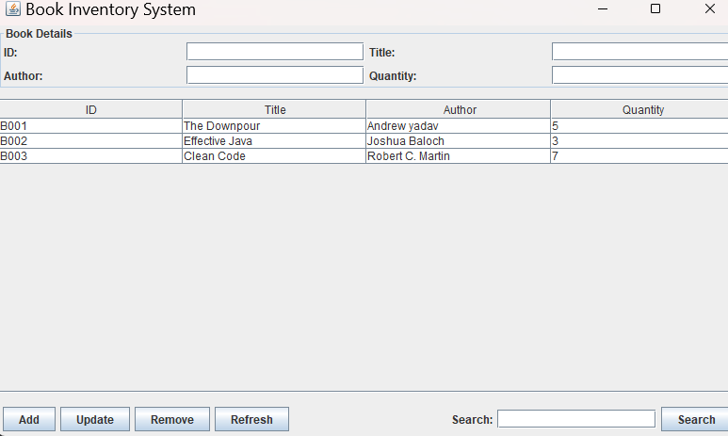
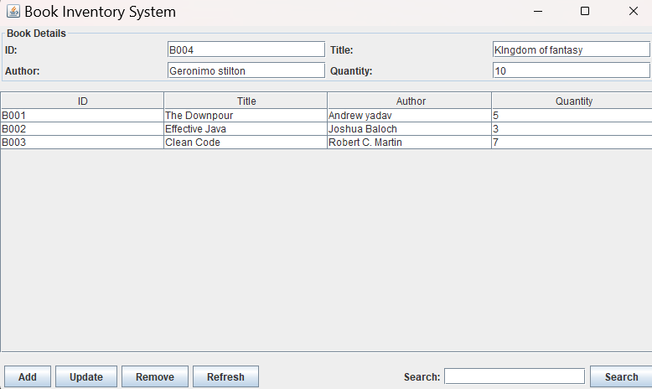
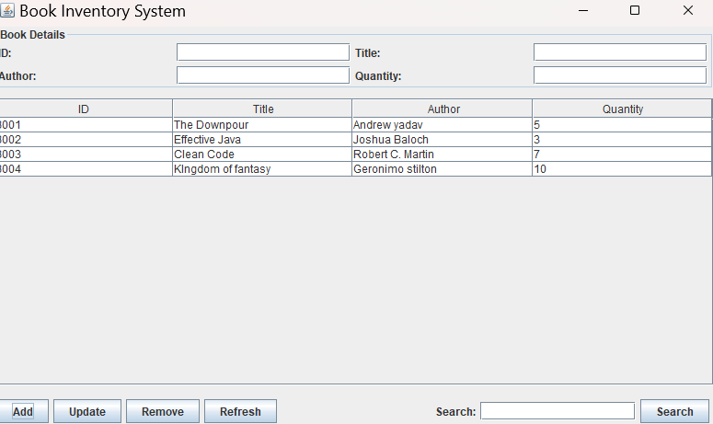

11. Testing Approach
Testing was performed by manually using the application and checking whether each feature worked as expected.
Test Case | Input/Action | Expected Result
Add book | Enter valid book details | Book is added
Duplicate ID | Enter existing ID | Error message displayed
Empty fields | Leave required field empty | Error message displayed
Negative quantity | Enter -5 | Error message displayed
Invalid quantity | Enter abc | Error message displayed
Update book | Change book details | Book information updated
Remove book | Select and remove book | Book deleted after confirmation
Search by ID | Enter book ID | Matching book displayed
Search by title | Enter title/keyword | Matching books displayed
Search by author | Enter author | Matching books displayed
Case-insensitive search | Use uppercase/lowercase | Matching result displayed
Refresh | Click Refresh | Complete inventory displayed
The testing showed that the main functions of the application work correctly with both valid and invalid inputs.

12. Challenges Faced
During development, a few challenges were faced.
Creating the GUI
Designing the Swing interface and arranging all the components properly required understanding different layout managers such as BorderLayout, GridLayout, and FlowLayout.
Table Management
Keeping the JTable synchronized with the ArrayList was another challenge. The refreshTable() and populateTable() methods were used to solve this.
Input Validation
The program needed to handle cases such as empty fields, duplicate IDs, negative quantities, and non-numeric quantities.
Updating and Selecting Books
Making the selected table row automatically fill the input fields required handling the table's selection events.
Search Functionality
The search needed to work with multiple fields and should not depend on uppercase or lowercase letters.

13. Learnings & Key Takeaways
This project helped in understanding several important programming concepts.
- Learned how to create a desktop GUI using Java Swing.
- Learned how to use JFrame, JButton, JTextField, JTable, and other Swing components.
- Understood how ArrayList can be used to store and manage objects.
- Practiced object-oriented programming through the Book class.
- Learned how event listeners work in GUI applications.
- Understood basic CRUD operations.
- Learned how to validate user input.
- Practiced handling errors using dialog boxes.
- Learned how different layout managers are used to organize GUI components.
- Understood how to design and test a small software project.
Overall, the project provided practical experience in connecting a graphical interface with application logic and data management.

14. Future Enhancements
The current application can be improved in several ways.
Database Integration
A database such as MySQL or SQLite could be added so that book information is permanently stored.
Login System
A username and password system could be added to control access to the application.
More Book Details
Additional information could be included, such as:
- ISBN
- Price
- Publisher
- Category
- Publication year
Better GUI
The interface could be improved with a more modern design, icons, better colors, and improved layouts.
Reports
The system could generate inventory reports showing total books, available quantities, and other statistics.
Sorting and Filtering
Users could be given options to sort books by title, author, quantity, or ID.
Data Backup
The application could provide options to export and import inventory data.

15. References
The following resources were used for understanding Java and Swing concepts during the development of this project:
- Oracle Java Documentation — Java SE Documentation
https://docs.oracle.com/en/java/
- Oracle Java Swing Documentation — Swing GUI Components
https://docs.oracle.com/javase/tutorial/uiswing/
- Oracle Java Collections Framework Documentation
https://docs.oracle.com/javase/tutorial/collections/
- Java ArrayList Documentation
https://docs.oracle.com/en/java/javase/

